**Base Compress Example Problem**

This example problem shows vessels growing within an angio material that contracts after time 1.

**Geometry**

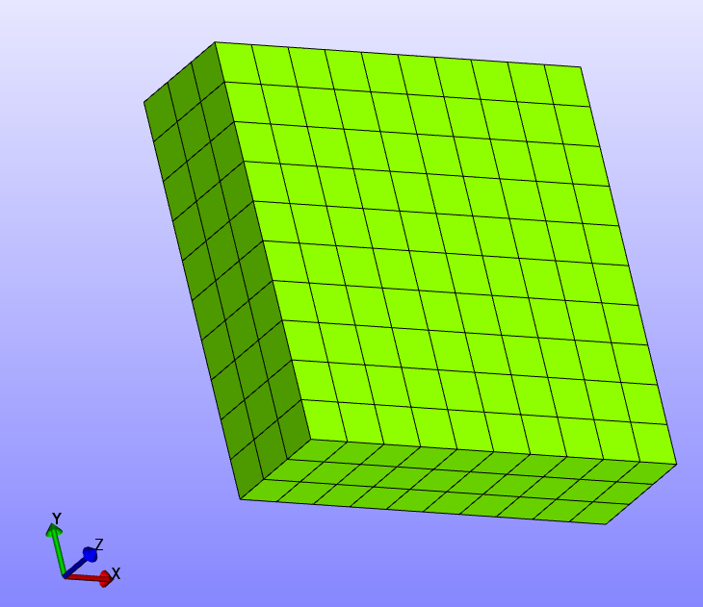

**Boundary Conditions**

-Z face fixed in z direction

+X face prescribed displacement in x to 30% after transition, fixed in z.

-X face fixed in x,y,z

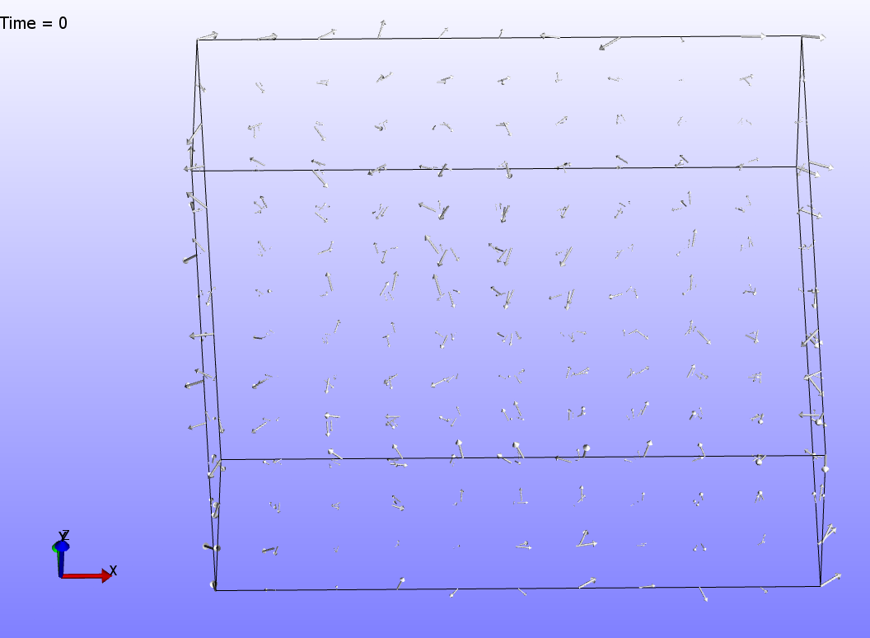

A visualization of the fibers in this model at the initial timestep.

**Material(s)**

The material used in this model is an angio material.

**Results**

A component of the rate at which vessels grow is determined by the material density. As such this component is changed by contracting the gel.